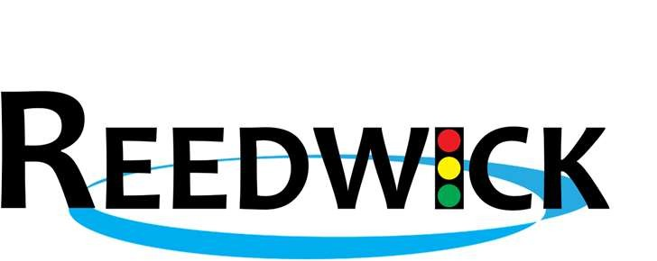

Reedwick, LLC is an Electrical Construction Company, specializing in the construction and maintenance of Intelligent Transportation Systems (ITS) and traffic signalization. We are currently seeking General Laborers, Technician Trainees, and ITS Traffic Signal Technicians to join our team.
This is THE BEST career move for qualified professionals in the Traffic Signal industry.
Our employees work hands on with Traffic Signal equipment, including installation of signal heads, pedestrian heads, wiring, cabling, span wire installation, strain poles, conduits, electrical service requirements, overhead lighting projects, and loop installations. Our technicians operate heavy equipment such as bucket trucks, line trucks and mini excavators. All members of our team work outside in various weather conditions. We supply appropriate PPE for team members seasonally. For our more advanced positions, the qualified candidate will also have knowledge and ability to set up traffic control flagging operations and work zone safety. Strenuous work is expected with heavy lifting and bending.
Reedwick, LLC offers our workforce top hourly pay with a clear direction for growth and opportunity. You will be working with industry professionals who share their knowledge and expertise with you as well.
We offer a comprehensive benefits package including health, dental and vision. Reedwick provides all employees Gold Memberships to the US Med Clinics in Villa Rica, Carrollton, and Rome, Ga. We also offer additional benefits, including 401K, short term disability, supplemental insurance, and life insurance. Our employees receive paid vacation & sick leave (accrued monthly) and 7 days of Holiday pay. Bring your industry experience and see what it's like working for a company who values you.
Job Type: Full-time Hours: 6:45am-6:30pm Monday-Thursday
Our office is located in
Villa Rica, GA.

*We have a 4 day, 10hr day work week Monday- Thursday and Flexible with Friday’s. We work very hard to then enjoy most Fridays off. We are on call as emergency responders for traffic signal issues in various districts throughout the state of Georgia. On occasion, we require overtime. Travel is not a norm, but when required, Reedwick, LLC pays all expenses & we give a week in advance notice if we are going out of town.

Salary: Depends on experience. Submit your resume with salary requirements and see what we can do.
Experience:
- 3 years + (Preferred) for our ITS Traffic Signal Technician Sr.
- 1-2 years + (Preferred) for our Skilled Traffic Signal Technician
- We have great opportunity for a Technician Trainee to get on the job training, so your able to grow with-in the company as long as you have the aptitude to learn & to be Self-motivated.
Reedwick, LLC is an EOE/E-Verify/Drug Free Employer. A background check is required. A MVR is also required for review. We conduct a pre-employment drug screen and send all new employees for a DOT physical.
This career move is ideal for someone who loves outdoor work, is driven, dependable, detail oriented, interested in construction, and motivated to work in a team environment.
For more information, contact our Human Resources:
Ms. Ashley Ward at Award@reedwick.com
Phone: 770-398-8792

-or-
Come by our office & pick up an application located at: 15071 Veterans Memorial Hwy, Villa Rica, GA 30180 Between the hours of:
Mon-Thursday 7:30am-5:00pm
Also, check us out online: www.reedwick.com or www.facebook.com/ReedwickLLC

